MACHINE LEARNING PROJECT 1

Machine Learning Project

Muhammad Zain Ul Hassan

Reg : SP19-BCS-033

Department of Computer Science

Submitted to: Dr. Muhmmad Azhar, PhD

Department of Computer Science

COMSATS University Islamabad, Sahiwal Campus.

MACHINE LEARNING PROJECT

Abstract

In this project, we were asked to experiment with a real world dataset, and to explore how machine learning algorithms can be used to find the patterns in data.
In the current world, there is a need to analyze and extract information from data. Clustering is one such analytical method which involves the distribution of data into groups of identical objects. Every group is known as a cluster, which consists of objects that have affinity within the cluster and disparity with the objects in other groups. The two major categories of clustering approaches are partition and hierarchical clustering. The algorithms which are dealt here are: k-means clustering algorithm, hierarchical clustering algorithm, density based clustering algorithm, self-organizing map algorithm, and expectation maximization clustering algorithm. All the mentioned algorithms are explained and analyzed based on the factors like the size of the dataset, type of the data set, number of clusters created, quality, accuracy and performance. This paper also provides the information about the tools which are used to implement the clustering approaches. The purpose of discussing the various software/tools is to make the beginners and new researchers to understand the working, which will help them to come up with new product and approaches for the improvement.

Motivations

we have data that contain the feature of 'homeshop','storeshop','employed', 'income', 'location', 'size' ,'age'. we have to find clusters from this data.we do not know the useful analysis from this data. The aim is to use machine learning algorithms to predict the clusters from data.

Data Analysis

DataSet

For this Purpose, we are using the dataset 'dataset_FreshCo (1).csv'.The dataset consist of several independent Variable include:

- Homeshop
- Storeshop
- Employed
- Income
- Location
- Size
- Age

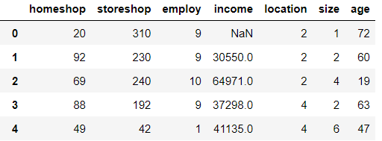

Data Cleaning
There are several ways to handle Null or Missing Values in the dataset. We Discussed only few of them.

7 Ways to Handle Missing Values in Machine Learning:

  - Deleting Rows with missing values

  - Impute missing values for continuous variable

  - Impute missing values for categorical variable

  - Other Imputation Methods

  - Using Algorithms that support missing values

  - Prediction of missing values

  - Imputation using Deep Learning Library — Datawig

From the up Ways we are using only one of them for Data Cleaning.There are only one feature that contains Null values , 'income'.

For cleaning the Null values from income we uses the " Impute missing values for continuous variable"

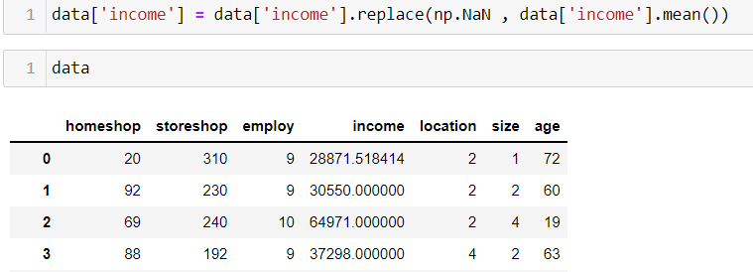

Visualization

Correlation of Data
Correlation explains how one or more variables are related to each other. These variables can be input data features which have been used to forecast our target variable.
Correlation, statistical technique which determines how one variables moves/changes in relation with the other variable. It gives us the idea about the degree of the relationship of the two variables. It’s a bi-variate analysis measure which describes the association between different variables.

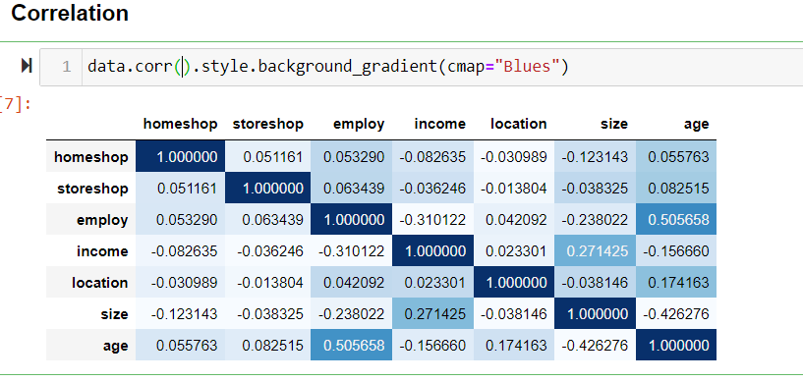

Heat Maps
Seaborn is a wonderful visualization library provided by python. It has several kinds of plots through which it provides the amazing visualization capabilities. Some of them include count plot, scatter plot, pair plots, regression plots, matrix plots and much more. 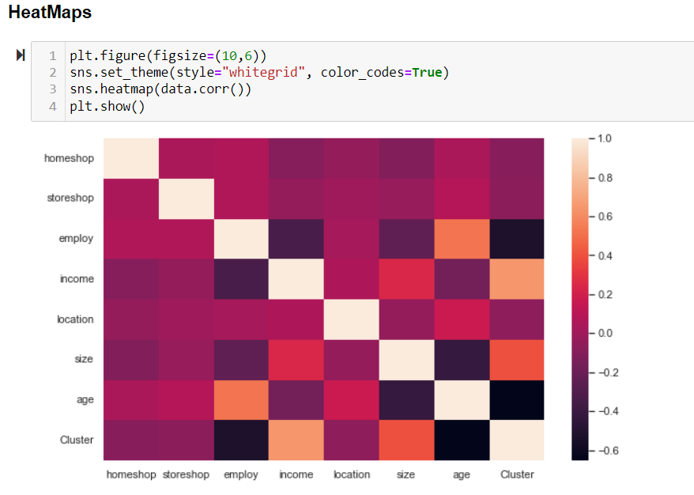

Outliers
An outlier is a data point that is noticeably different from the rest. They represent errors in measurement, bad data collection, or simply show variables not considered when collecting the data.

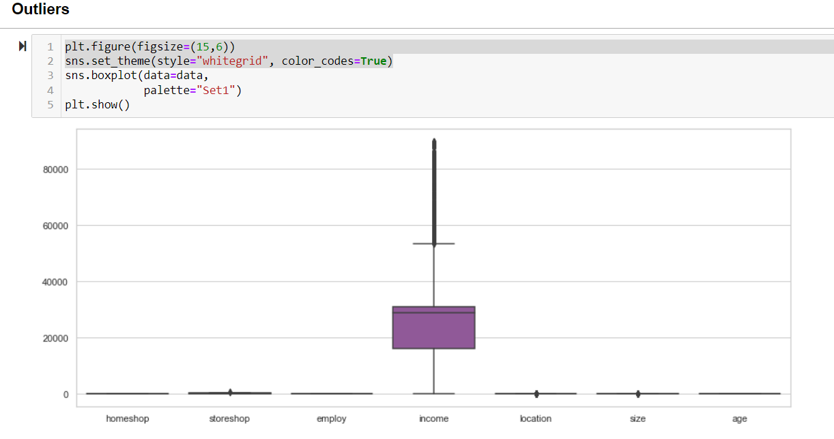

In the above Graph, there is only outliers occurs in one feature ,"Income".

There are some techniques used to deal with outliers.

- Deleting observations.
- Transforming values.
- Imputation.
- Separately treating.
- Deleting observations. Sometimes it's best to completely remove those records from your dataset to stop them from skewing your analysis.

Data Preprocessing
Feature Scaling
Feature scaling is a method used to normalize the range of independent variables or features of data. In data processing, it is also known as data normalization and is generally performed during the data preprocessing step.

It is used when our data is not normalized and there is huge difference between the maximum values of features in the dataset.

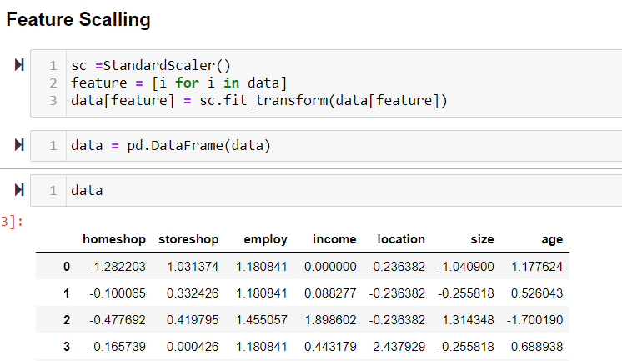

Model Building
The two major categories of clustering approaches are partition and hierarchical clustering. The algorithms are

- k-means clustering algorithm
- hierarchical clustering algorithm
- density based clustering algorithm
- self-organizing map algorithm
- expectation maximization clustering algorithm.

But for this dataset we uses the k-mean clustering algorithm.

k-means clustering algorithm

K-means algorithm is an iterative algorithm that tries to partition the dataset into K pre-defined distinct non-overlapping subgroups (clusters) where each data point belongs to only one group. It tries to make the intra-cluster data points as similar as possible while also keeping the clusters as different (far) as possible.

- Specify number of clusters K.
- Initialize centroids by first shuffling the dataset and then randomly selecting K data points for the centroids without replacement.
- Keep iterating until there is no change to the centroids. i.e assignment of data points to clusters isn’t changing.

How can find the appropriate value of K in the K-mean Algorithm?

It is a common problem that we face in k-mean Algorithm. There are two ways to solve this problem.

Techniques for finding the Optimal Value of k:

- Elbow Method
- Silhouette Method

We use Elbow Method for finding the optimal Value of K in K mean Algorithm, for this dataset.

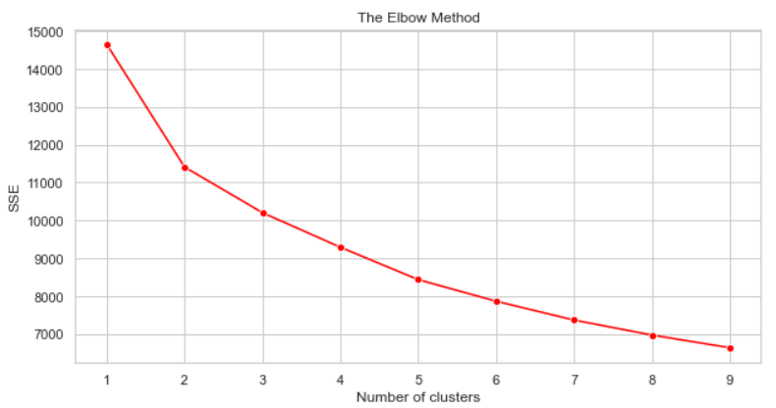

Implementation of k-mean Clustering:

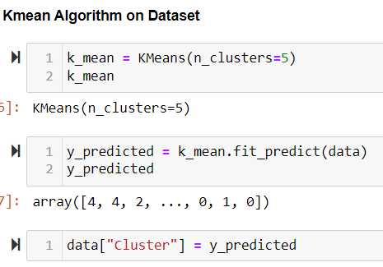
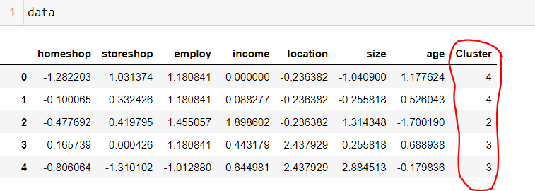

K-mean Cluster on Two Feature:

We can apply K-mean Algoritms on two feature that are very important , "income" and "age".

Implementation of k-mean Clustering on "income" and "Age":

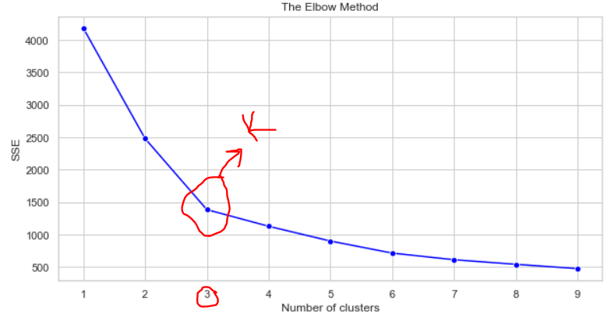

So in the above graph of Elbow Method on two Feature , its indicate that the value of K in K-mean is "3".

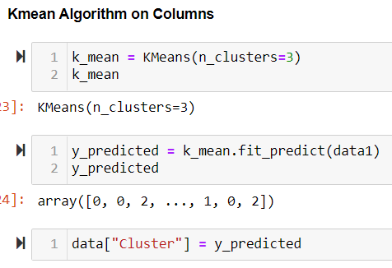

Visualization of Clustering between 'income' and 'Age'

